Solar Food Dryers

Solar food dryers are easy to build, and are a very efficient way to preserve food, especially as the relentless summer sun in Paraguay moves toward the summer solstice. At latitudes south of the Tropic of Capricorn, the apex of the sun reaches its highest point in the sky on December 21st, the summer solstice, giving Paraguay almost direct sunlight. The northern reaches of Paraguay are within the Tropic of Capricorn, which means on the summer solstice the sun will pass directly overhead, and its energy reaches the earth at a ninety-degree angle. Further south, at the latitudes of Caacupe and Coronel Oviedo, the angle of the sun’s energy is approximately 88°, while even further south such as Encarnación, the sun’s angle on the summer solstice is around 86°. This all means that the Paraguayan summer sun is a very effective asset for drying food. Availability of dried ingredients such as, sun dried tomato, mango, pineapple, banana, apple, etc., can enable volunteers as well as Paraguayans to be much more creative with their cooking, and also preserve food, enhancing food security.

How a solar dryer works

The solar dryer consists of a wooden base, two wooden sides, two vents on the lower and upper side, and a glass face. The shelves are angled at 30°, because when the solar dryer is in use, it sits at a 30° angle, making the shelves parallel to the ground. The sun’s energy enters through the glass, and heats up the air inside the box. Since air rises when it heats up, cooler air entering through the lower vent will heat up, rise, and exit through the upper vent. The combination of the sun’s energy and the movement of air is what efficiently dries the food inside. Both the sun’s energy and the movement of air are equally important to the drying process. Without the movement of air, the food inside would cook rather than dry.

Factors affecting how quickly food dries

There are a variety of factors that affect how quickly food dries in a solar dryer, including the date, presence of clouds, air temperature, what food is being dried, and the size of what is being dried.
- Date - Due to the sun’s annual path through the sky, the most efficient period of time in which to dry food is November 21st until March 21st, thirty days before the summer solstice until the end of summer. It is certainly still possible to dry food during other parts of the year, but during this time period food will dry more quickly due to the more direct nature of the sun’s energy.
- Presence of Clouds - The presence of clouds has a negative effect on drying food. The name solar dryer, means that the sun is a necessary element, and on overcast days, clouds obstruct how the sun’s energy is received on the Earth, because clouds filter out a portion of the UVA and UVB energy the sun emits.
- Temperature also has an impact on the drying process. Food being dried on hotter days will dry more quickly than food being dried on cooler days. Temperature is very much affected by the date, and the presence of clouds, so this could be considered a restatement of numbers 1 and 2.
- Type of Food - What food is being dried also has an effect on the time it takes to dry food. Food that contains more moisture, will take longer to dry than food that contains less moisture.
- Size of Food - There is also a positive correlation between the size of the food, and the amount of time in which the food dries. Food sliced into thinner, smaller pieces, will dry more quickly than food sliced into thicker, larger pieces.

How to build a solar food dryer

Materials
- Wood
- Glass
- Rubber
- Window Screen (Tela Mosquitera para ventanas)
  - Most mosquito nets are sprayed with a toxin that kills insects. Therefore cutting costs by using a Peace Corps issued mosquito net is not the best idea. Tela Mosquitera para ventanas is very inexpensive. In Itacurubi de la Cordillera, one square meter costs 3.500 Guaranies.
- Nails

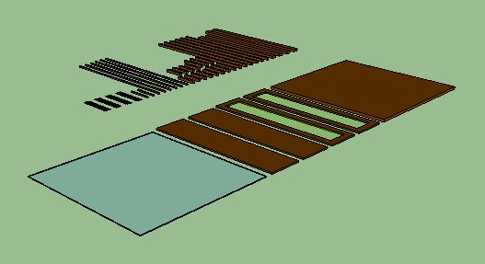
Materials

Measurements (cm)
Name |  | Length |  | Width | Thickness | Quantity
A |  | 100 |  | 100 | 1 | 1
B |  | 102 |  | 25 | 1 | 2
C |  | 100 |  | 25 | 1 | 2
D |  | 100 |  | 5 | 2 | 2
E |  | 90 |  | 5 | 2 | 2
F |  | 100 |  | 2 | 2 | 6
G |  | 20 |  | 2 | 2 | 6
H |  | 16 |  | 2 | 2 | 9
I |  | 100 |  | 1 | 1 | 3
J |  | 98 |  | 1 | 1 | 3
K |  | 18 |  | 1 | 1 | 2
Glass |  | 98 |  | 98 | 0,4 | 1
Rubber |  | 25 |  | 5 | - | 4
Mosquitero Cloth |  | 200 |  | 100 | - | 1
Measurements |  |  |  | 100 | 100 | 25
Nails | 1"
Nails | 1.5"

  - for ventilation, the center is cut out of piece B, leaving a 5 cm wide frame
Construction
- Build 3 shelf frames using part F_{1,2,3,4,5,6} and part H_{1,2,3,4,5,6,7,8,9}
  - attach the window screen to the shelf frames

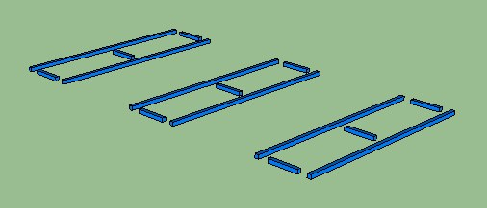
Step 1

- Build ledges for the shelves at a 30° angle in the wall of the solar dryer using part C_{1,2} and part G_{1,2,3,4,5,6}
  - this may be the most important step
  - parts G_{1,2,3,4,5,6} need to rest at a 30° angle, and need to be spaced out in such a way that they don’t overlap each other
  - they also have to be exact mirror images of each other, or else the shelves will not sit properly on the ledges (part G_{1,2,3,4,5,6})

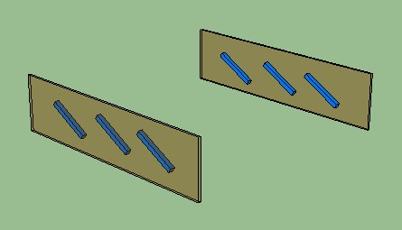
Step 2

- Attach the walls to the base, using part A

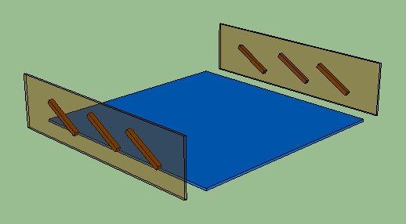
Step 3

- Reinforce the joints of the solar dryer with part I_{1,2} and part J₁

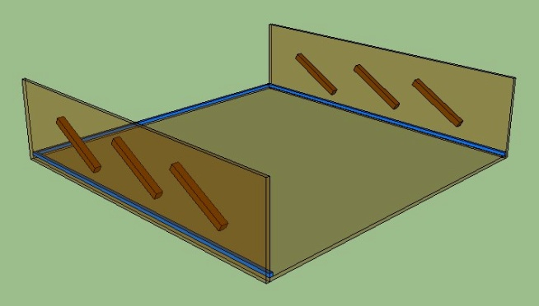
Step 4

- Attach part B₁ to the solar dryer
  - this will be the lower vent, in which cool air enters
  - attach screen before attaching part B₁

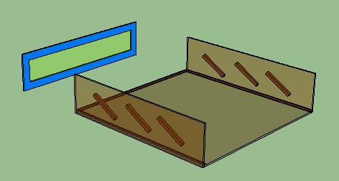
Step 5

- Attach part K _{1,2} part E₁ and part J₁ to part B₂
  - this will be the upper vent, from which warm air and humidity exits
  - attach screen to part B₂ before attaching parts K_{1,2}, E₁ and J₁
  - leave a 1cm wide gap in between parts K_{1,2}, E₁, J₁ and the edge of part B₂

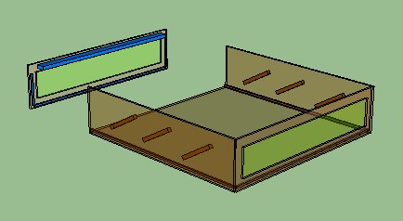
Step 6
(Reverse Angle)

- Attach part D_{1,2} and part E₂ into the solar dryer
  - leave a 1 cm wide gap in between part D_{1,2} E₂ and the upper edge of the solar dryer

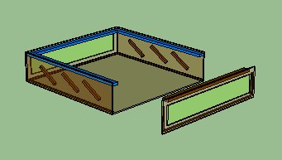
Step 7

- Put the shelves in place and close the solar dryer by joining part B₂ with the solar dryer
  - it is important not to glue or nail this piece in place
  - this piece needs to be removable so that the shelves can be removed
  - the shelves need to be removable so that the window screen can be changed easily

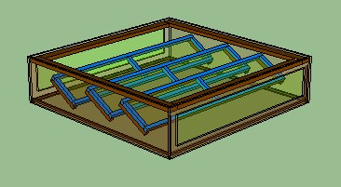
Step 8

- Position the rubber strips in place in the corners of the solar dryer where part D_{1,2} and E_{1,2} meet
  - this is so the glass will not slide, and also to lessen the risk of scratching
  - these do not need to be glued or nailed in place, they can be put in place every time the solar dyer is used, and taken off during storage

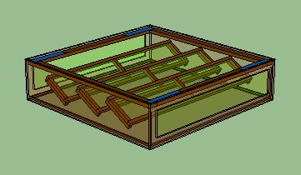
Step 9

How to set up and use a solar dryer

- Position the solar dryer at a 30° angle
- Place shelves on the ledges the rest on
- Join the upper ventilation piece with the solar dryer
- Place food on shelves
- Put rubber pieces in place in the corner
- Put glass in place
- The solar dryer will have to be moved throughout the course of the day, to ensure that the face is always receiving complete sunlight, and there are no shadows over any of the food in the solar dryer

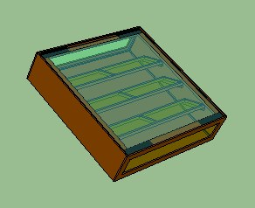
Solar Dryer

